

BUMK770: Retail Analytics

Case Analysis II: H-E-B Own Brands

Professor Jie Zhang
Group D

Heven Abraha
Nia Bishop
Victoria Rush
Julia See

Monday, April 27, 2026

By including my name on this work, I certify that I have been an active team member.

Honor Pledge:

We pledge on our honor that we have not given or received any unauthorized assistance on this project.

Executive Summary

H-E-B’s success is strongly supported by its private-label strategy, “Own Brands,” which includes the premium-tier H-E-B and value-tier Hill Country Fare. These brands contribute uniquely by generating higher margins than national brands, strengthening customer loyalty, and reducing dependence on external suppliers, while national brands provide recognition, trust, and store traffic through established demand and promotions. Across categories such as flour and canned vegetables, the Own Brand strategy is most effective when clear pricing tiers and shelf adjacency are maintained, with H-E-B positioned as a national-brand equivalent and Hill Country Fare targeting price-sensitive shoppers. The Glacia case highlights the risks of weak differentiation within tiers, as Glacia was intended as a premium imported alternative, but instead blurred positioning and cannibalized both Evian and Ozarka. Moving forward, Glacia should be repositioned as a clearly defined premium import with stronger origin signaling and pricing closer to Evian to establish a clear hierarchy within the premium segment. In the broader bottled water category, H-E-B should avoid adding premium products under Hill Country Fare and instead expand it within the growing purified water segment, where demand is increasing alongside brands like Aquafina. H-E-B’s Own Brand strategy is most effective when strict segmentation, pricing, and clear shelf positioning are used to maximize profitability while minimizing cannibalization.

Introduction / Background
H-E-B is a Texas-based grocery retailer that has grown from a small family-owned business founded in 1905 into one of the leading regional supermarket chains in the United States. The company is known for its focus on everyday low prices, quality, and customer service. A key driver of its success is its private-label portfolio, known as “Own Brands,” which includes the premium-tier H-E-B and the value-tier Hill Country Fare. The Own Brands contribute to H-E-B’s business by generating higher margins, reducing reliance on national manufacturers, and strengthening customer loyalty through exclusive offerings (Rangan & Bell, 2002). The H-E-B brand competes in premium and mainstream segments by matching or exceeding national brand quality, while Hill Country Fare targets price-sensitive consumers with lower-priced alternatives that drive volume.
National brands provide strong recognition, consumer trust, and act as traffic drivers through advertising support and manufacturer-funded promotions. They are particularly important in categories where familiarity and perceived quality strongly influence purchasing decisions. The distinction between Own Brands and national brands is especially evident in commodity categories such as flour and canned vegetables, where price drives choice. In these categories, Hill Country Fare captures value-driven demand, while H-E-B Own Brands balance quality and margin objectives. This dynamic highlights the importance of clear brand positioning to ensure Own Brands enhance profitability without undermining category performance (Rangan & Bell, 2002).
Analyses and Findings
- Flour
The retailer should offer both the H-E-B brand and the Hill Country Fare (HCF) brand. The H-E-B flour serves as H-E-B’s premium private label, while Hill Country Fare serves as H-E-B's economy private label. H-E-B is priced at $0.99, in between the price range of the leading brands, while HCF is priced lower at $0.87. Both of these private label brands produce the same unit margin of 18%, indicating they contribute to the retailer more than double the profit compared to the leading brands. In addition to their profitability, the H-E-B brand should be kept, as its sales continue to increase over the last three years, moving from $609,000 to $661,000. While HCF's sales have shown a slight decline, its sales are a larger portion, with sales from $864,000 dropping to $840,000. Despite this, as a value private label, HCF is consequential to the customer retention and price elasticity of H-E-B. The elimination of this brand could cause shoppers who don’t want to pay over 90 cents for flour to go to other stores. Which is why, despite its slow drop in sales, it should be maintained as a private label offer, as it still brings in larger sales than H-E-B and maintains the same amount of profitability.
The leading brands in this category range from $0.98 to $1.17. When the national brands are at the top of that range ($1.17), the current private label pricing is effective. At $0.99, H-E-B is 15% less expensive than the national brands. As a premium private label, it could even raise its price up to $1.05 and remain competitive and profitable at a 10% discount. HCF, at $0.87, offers a 25% discount over the leading brands, making it very attractive for price-sensitive customers. However, if leading brand prices are closer to $0.98, prices of the two private labels should be adjusted. At this leading brand price, the H-E-B brand is more expensive, removing the value proposition of a private label brand. Instead, the H-E-B brand should be priced around $0.88, 10% less than the leading brand. HCF should be lowered to $0.78 or lower to maintain its value as a private label identity. This price is 20% less than the leading brand price and would clearly communicate its price advantage to those price-sensitive consumers.
The current shelving of the private brands, compared to the leading brands, is good but could improve. The HEB flour is in the ideal row (eye level) with the HCF flour in the next favorable row. However, the leading brand is to the right of the private labels. HEB should swap the slides of the HCF brand and the leading brand so that the HCF brand is on the right. For most American consumers, they read the shelves like a book, from left to right, so currently their eyes will end on the leading brand (Gold Medal), leaving that final image in their minds. Switching the positions leaves the leading brands at the forefront of the consumers' minds. This positioning also allows consumers to first read the price of the leading brand, notice the stark contrast with the private brands, and understand the savings they will receive.
- Canned Vegetables
H-E-B should maintain both the premium tier offerings H-E-B and the value tier offerings Hill Country Fare because they serve distinct customer segments and play complementary roles in the retailer’s overall strategy. The H-E-B brand functions as a national-brand equivalent, offering high quality that competes directly with established manufacturers and strengthening customer perception of H-E-B as a premium retailer. Hill Country Fare targets highly price-sensitive shoppers with the lowest-priced options, helping H-E-B retain customers who might otherwise switch to competitors such as Walmart. Eliminating either brand would weaken this “good-better-best” structure: removing H-E-B would reduce premium differentiation and margin opportunities, while removing Hill Country Fare would risk losing value-driven customers. The two brands allow H-E-B to cover the full market spectrum, from quality-focused to price-sensitive consumers, while maximizing both loyalty and category penetration.
H-E-B brands should each be positioned at distinct price levels relative to national brands to maintain a clear tiered structure and guide consumer choice. Own Brands should be priced slightly below leading national brands, typically about 10–15% lower, to communicate comparable quality while offering moderate savings to encourage substitution. Hill Country Fare should be priced significantly lower, around 20–30% below national brands, to clearly indicate its role as the price sensitive alternative. This structured pricing approach reinforces a “good-better-best” hierarchy, making it easy for shoppers to distinguish between premium and value offerings. Clear and meaningful price gaps are essential to prevent brand overlap and to motivate consumers to trade down from national brands into the appropriate private-label tier.
The case and Exhibit 7 emphasize “brand adjacency” as a key shelf strategy, where store brands are placed directly alongside leading national brands. In categories such as flour and canned vegetables, positioning H-E-B products at eye level next to category leaders increases price visibility and encourages direct comparison, supporting substitution toward Own Brands. For Hill Country Fare products, a lower shelf placement reinforces their value positioning and aligns with their role as a budget-oriented option within the assortment. Across categories, H-E-B should maintain a clear shelf hierarchy that separates value, standard, and premium tiers to minimize confusion and strengthen brand roles, ensuring each Own Brand competes against the appropriate national benchmark.

Glacia Analysis and Recommendations

The Glacia brand faces a problem with its positioning, but unfortunately, it missed the mark from its desired premium positioning and the actual consumer perception. Although it was intended to be developed and sourced as a premium imported spring water brand, to be compared to Evian, the customers could not distinguish or recognise it, and the majority of the consumers believed it was originally from Texas instead of Canada (Rangan & Bell, 2002). The lack of awareness weakened its ability to compete in the premium imported segment and instead was in direct competition with domestic brands like Ozarka, which were priced lower. Glacia was successful in capturing volume but failed to fully leverage its premium attributes. Glacia’s current positioning created an internal conflict within the category by drawing sales away from the higher-margin imported brands such as Evian. This has led to inefficient segmentation, customer confusion, and suboptimal profitability despite the strong unit margins.
Glacia should then be repositioned as a premium imported spring water to align with its product quality and original strategic intent. Emphasizing its Canadian origin with more clarity through its packaging, labeling, and overall marketing, and in doing so, it was shown to appeal strongly to the premium water consumers (Rangan and Bell, 2002). Pricing-wise, Glacia should be priced closer to Evian within the imported water segment, rather than alongside domestic spring waters, and in doing so, reinforce its premium positioning and improve customer understanding.
H-E-B can address Glacia’s impact on Evian by establishing clearer positioning for each brand within the premium segment instead of allowing overlap with clear differentiation of the roles for both products within the premium segmentation, rather than allowing them to compete directly. Evian should be in the ultra-premium positioning, and since it is already globally recognised, it should have a higher price and status. Evian’s origin in the French Alps should be emphasized to consumers. Glacia should be offered with lower pricing as an alternative premium commodity that captures more value-conscious shoppers within the imported segment. In doing this, there will be a clear price and quality ladder between the two brands, and H-E-B can minimise direct substitution and instead encourage trade-down within the premium tier rather than complete switching out of it. Targeted promotions by H-E-B can support Evian and maintain its visibility to preserve its high-margin contribution, while also allowing Glacia to expand the overall imported water segment. The shelving for Evian and Glacia should not be side by side leading consumers to see both brands as direct competitors. Evian should be placed eye level near imported and luxury waters, while Glacia is placed with other value-premium water options. Evian can capitalize on higher margins with image driven purchases through bottles with one serving, contrasting Glacia’s multi-packs to limit comparable SKU’s. H-E-B can encourage Glacia’s growth by redirecting consumers through clear differentiation methods.
H-E-B should refine its bottled water strategy by aligning closely with the evolving segment dynamic observed after the launch of Glacia to remain competitive. The decline in share for Evian and Ozarka, alongside gains by Aquafin, indicate growing consumer demand for everyday low pricing options in comparison to purely premium water. According to Table G, Glacia is pulling sales from both premium (Evian) and mid tier water (Ozarka), while purified/ functional water (Aquafina) is simultaneously growing due to price sensitive consumers. H-E-B should avoid introducing a premium product under Hill Country Fare, resulting in blurred value positioning. The retailer should expand Hill Country Fare in the purified segment offering a low price, multi-pack option for convenience driven purchase decisions. H-E-B would be able to compete directly with Aquafina and capture high volume sales. Glacia should be repositioned to minimize overlap with Evian by emphasizing value-premium attributes, white Evian is positioned as a high margin product from the French Alps. "H-E-B had three major objectives for its Own Brand product lines: improved profitability, sales growth, and deeper customer relationships" (Bell & Rangan, 2003, p. 10). H-E-B’s new strategy should prioritize clear segmentation, stronger participation in purified water, and reduced overlap across tiers to align with consumer preferences and maximize category profitability.

Appendices
Figure 1: H-E-B Brand Quality Comparisons
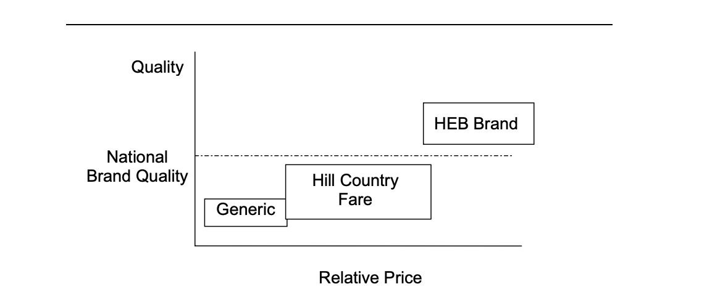
Figure 2: H-E-B Brand Price Comparisons (Flour and Canned Vegetables)
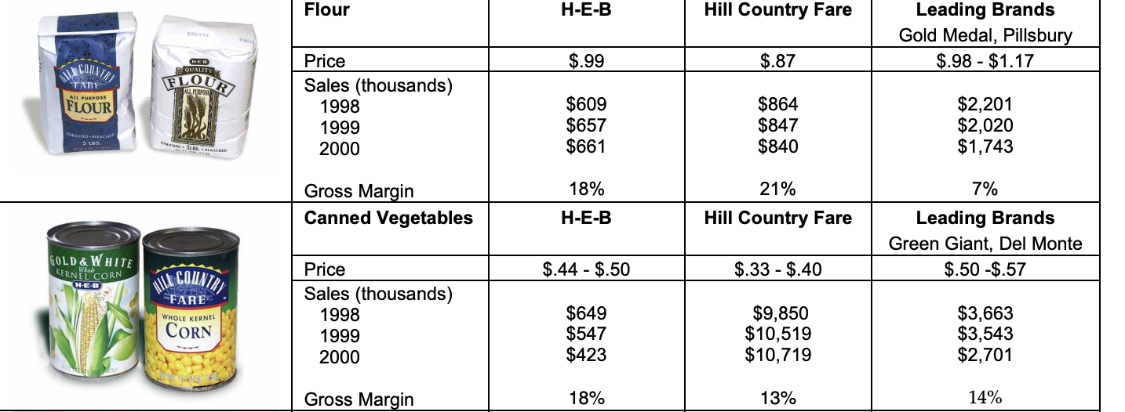
Figure 3 : Bottled Water Comparison
